**Oracle Database & Queries**

SCHOOL ADMINISTRATOR

DISCIPLINE ABOUT ALL STUDENTS FOR ADMIN

--TOP DISCIPLINE EVENT HAPPEND

SELECT COUNT(FD.DISCIPLINEID) AS NUMBEROFDISCIPLINE,DE.DISCIPLINEEVENTDESC,FD.DISCIPLINEEVENTCODEID

FROM FACTDISCIPLINE AS FD

JOIN DIMDISCIPLINEEVENTCODE AS DE

ON FD.DISCIPLINEEVENTCODEID= DE.DISCIPLINEEVENTCODEID

GROUP BY FD.DISCIPLINEEVENTCODEID,DE.DISCIPLINEEVENTDESC

ORDER BY COUNT(FD.DISCIPLINEID) DESC;

--EVERY YEAR THE TOP HAPPEND DISCIPLINE EVENTS INCLUDING TOTAL NUMBER

SELECT DATEPART(YYYY,FD.EVENTDATE) AS EVENTYEAR,COUNT(FD.DISCIPLINEID) AS NUMBEROFDISCIPLINE,DE.DISCIPLINEEVENTDESC,FD.DISCIPLINEEVENTCODEID

FROM FACTDISCIPLINE AS FD

JOIN DIMDISCIPLINEEVENTCODE AS DE

ON FD.DISCIPLINEEVENTCODEID= DE.DISCIPLINEEVENTCODEID

GROUP BY FD.DISCIPLINEEVENTCODEID,DE.DISCIPLINEEVENTDESC,DATEPART(YYYY,FD.EVENTDATE)

ORDER BY DATEPART(YYYY,FD.EVENTDATE) DESC,COUNT(FD.DISCIPLINEID) DESC;

**--THE TOTAL NUMBER AND THE ORDER OF THE DISCIPLINE EVENT HAPPEND BY GENDER, GRADE, GRADUATIONPLANYEAR,HOMELESSSTUDENT**

**SELECT COUNT(FD.DISCIPLINEID) AS NUMBEROFDISCIPLINE,DS.GENDER,DS.GRADE,DS.GRADUATIONPLANYEAR,DS.HOMELESSSTUDENT**

**FROM FACTDISCIPLINE AS FD**

**JOIN DIMSTUDENT AS DS**

**ON DS.STUDENTID= FD.STUDENTID**

**GROUP BY GROUPING SETS(DS.GENDER,DS.GRADE,DS.CITIZENSHIPSTATUS,DS.GRADUATIONPLANYEAR,DS.HOMELESSSTUDENT)**

**ORDER BY DS.GENDER,DS.GRADE,DS.GRADUATIONPLANYEAR,DS.HOMELESSSTUDENT DESC**

SPECIAL PROGRAMS ABOUT ALL STUDENTS FOR ADMIN

ABSENCE OF ALL STUDENTS FOR ADMIN

----COUNT THE TOTALL NUMBER OF ABSENCE IN EVERY SCHOOL YEAR

**SELECT COUNT(*) AS NUMBEROFABSENCE,FA.ABSENCECODEID, DD.SCHOOLYEAR**

**FROM DIMDATE AS DD**

**JOIN FACTABSENCE AS FA**

**ON DD.DATEPK = FA.ABSENCEDATE**

**GROUP BY FA.ABSENCECODEID, DD.SCHOOLYEAR;**

COURSE GRADE MANAGEMENT FOR ADMIN

--AVERAGE NUMERICGRADE AND TOTAL NUMBER IN EVERY SUBJECT

**SELECT NEW1.SUBJECTNAME,AVG(NEW1.ALPHANUMERICGRADE) AS AVERAGEGRADE, COUNT(NEW1.STUDENTCOURSEGRADEID) AS NUMBEROFSTUDENTS**

**FROM (SELECT FSCG.STUDENTCOURSEGRADEID,FSCG.ALPHANUMERICGRADE,FSC.STUDENTCOURSEID,DS.SUBJECTNAME**

**FROM DIMSUBJECT AS DS**

**JOIN DIMCOURSE AS DC**

**ON DS.SUBJECTID= DC.SUBJECTID**

**JOIN FACTSTUDENTCOURSE AS FSC**

**ON FSC.COURSEID = DC.COURSEID**

**JOIN FACTSTUDENTCOURSEGRADE AS FSCG**

**ON FSCG.STUDENTCOURSEID=FSC.STUDENTCOURSEID) AS NEW1**

**GROUP BY NEW1.SUBJECTNAME**

**ORDER BY AVG(NEW1.ALPHANUMERICGRADE)**

TEACHER

2. FROM THE PERSPECTIVE OF TEACHER

A-QUERY ON ABSENCE MODEL: ABSENCE COUNTS OF STUDENTS UNDER SPECIFIED TEACHER (FOR EXAMPLE “ TAI LEE”) BY TIME (QUARTER/HALF YEAR/YEAR)

**SELECT COUNT(*) AS ABSENCETOTAL, SCHOOLYEARNAME, SCHOOLHALFYEARNAME ,SCHOOLQUARTERNAME FROM DBO.FACTABSENCE AS FA**

**JOIN DBO.DIMSTAFF AS DSF ON FA.STAFFID=DSF.STAFFID**

**JOIN DIMDATE AS DD ON FA.ABSENCEDATE=DD.DATEPK WHERE DSF.STAFFFIRSTNAME='TAI' AND DSF.STAFFLASTNAME='LEE'**

**GROUP BY ROLLUP(SCHOOLYEARNAME, SCHOOLHALFYEARNAME ,SCHOOLQUARTERNAME )**

**ORDER BY SCHOOLYEARNAME, SCHOOLHALFYEARNAME ,SCHOOLQUARTERNAME ;**

B- ANALYSIS ON RANKING DISCIPLINE COUNTS OF STUDENTS UNDER SPECIFIED TEACHER (FOR EXAMPLE “ TAI LEE”) BY CATEGORY:

**SELECT RANK() OVER(ORDER BY COUNT(DD.DISCIPLINEACTIONDESC)) AS COUNTRANKING, COUNT(DD.DISCIPLINEACTIONDESC) AS DISCIPLINEACTIONCOUNT, DD.DISCIPLINEACTIONDESC FROM FACTDISCIPLINE AS FD JOIN DIMSTAFF AS DSF ON FD.ACTIONSTAFFID=DSF.STAFFID**

**JOIN DIMDISCIPLINEACTIONCODE AS DD ON FD.DISCIPLINEACTIONCODEID=DD.DISCIPLINEACTIONCODEID**

**WHERE DSF.STAFFFIRSTNAME='TAI' AND DSF.STAFFLASTNAME='LEE'**

**GROUP BY DD.DISCIPLINEACTIONDESC;**

C-ANALYSIS:TOP COURSE GRADES BY GRADE TYPE IN ALL COURSES TAUGHT BY A SPECIFIED TEACHER(FOR EXAMPLE “ TAI LEE”):

**SELECT AVG (FSCG.NUMERICGRADE) AS AVERAGEGRADE**

**GRADE , COURSETITLE, DGT.GRADETYPE FROM**

**FACTSTUDENTCOURSEGRADE AS FSCG JOIN FACTSTUDENTCOURSE AS FSC ON FSCG.STUDENTCOURSEID=FSC.STUDENTCOURSEID**

**JOIN DIMSTAFF AS DSF ON DSF.STAFFID=FSC.STAFFID**

**JOIN DIMGRADETYPE AS DGT ON DGT.GRADETYPEID=FSCG.GRADETYPEID**

**JOIN DIMCOURSE AS DC ON FSC.COURSEID=DC.COURSEID**

**GROUP BY COURSETITLE,DGT.GRADETYPE**

**ORDER BY COURSETITLE,DGT.GRADETYPE**

D-QUERY: COUNT HOW MANY SECTIONS EACH PROGRAM HAS IN EVERY SCHOOL QUARTER:

**SELECT COUNT(*) , DSF.PROGRAM, SCHOOLQUARTERNAME FROM FACTSPECIALPROGRAM AS FSP JOIN DIMSPECIALPROGRAM AS DSF ON FSP.SPECIALPROGRAMID=DSF.PROGRAMID**

**JOIN DIMDATE AS DD ON FSP.ENTRYDATE=DD.DATEPK**

**GROUP BY DSF.PROGRAM, SCHOOLQUARTERNAME;**

PARENTS

--QUARY: PARENTS WANT TO KNOW HOW MANY THEIR CHILD "JESPER HERP" ABSENTED FROM CLASS BY DIFFERENT ABSENCE DESCRIPTION

**SELECT DIMABSENCECODE.ABSENCECODEDESC, COUNT(*) AS COUNT**

**FROM SCHOOLS_K12_DW.DBO.DIMABSENCECODE**

**JOIN SCHOOLS_K12_DW.DBO.FACTABSENCE**

**ON FACTABSENCE.ABSENCECODEID=DIMABSENCECODE.ABSENCECODEID**

**JOIN SCHOOLS_K12_DW.DBO.DIMSTUDENT**

**ON DIMSTUDENT.STUDENTID=FACTABSENCE.STUDENTID**

**WHERE DIMSTUDENT.STUDENTNAME = 'JESPER HERP'**

**GROUP BY DIMABSENCECODE.ABSENCECODEDESC;**

--QUARY: PARENTS WANT TO KNOW THEIR CHILD "JESEPER HERP" DISCIPLINE BY DIFFERENT DISCIPLINE EVENT DESCRIPTION IN SPECIFIC TIME.

USE SCHOOLS_K12_DW;

**SELECT DIMDISCIPLINEEVENTCODE.DISCIPLINEEVENTDESC, COUNT(*) AS COUNT**

**FROM FACTDISCIPLINE**

**JOIN DIMDISCIPLINEEVENTCODE**

**ON FACTDISCIPLINE.DISCIPLINEEVENTCODEID = DIMDISCIPLINEEVENTCODE.DISCIPLINEEVENTCODEID**

**JOIN DIMDATE**

**ON FACTDISCIPLINE.EVENTDATE = DIMDATE.DATEPK**

**JOIN DIMSTUDENT**

**ON DIMSTUDENT.STUDENTID = FACTDISCIPLINE.STUDENTID**

**WHERE DIMSTUDENT.STUDENTNAME = 'KIM ABERCROMBIE' AND DIMDATE.YEARNAME = 'CALENDAR 2008'**

**GROUP BY DIMDISCIPLINEEVENTCODE.DISCIPLINEEVENTDESC;**

--PARENTS WANT TO FIND ALL COURSE GRADE OF THEIR CHILD "NUPUR AGARWAL" ON SECOND SEMESTER

USE SCHOOLS_K12_DW

**SELECT DIMSTUDENT.STUDENTNAME, DIMCOURSE.COURSETITLE,DIMGRADETYPE.GRADETYPE, FACTSTUDENTCOURSEGRADE.NUMERICGRADE**

**FROM FACTSTUDENTCOURSEGRADE**

**JOIN FACTSTUDENTCOURSE**

**ON FACTSTUDENTCOURSE.STUDENTCOURSEID = FACTSTUDENTCOURSEGRADE.STUDENTCOURSEID**

**JOIN DIMGRADETYPE**

**ON FACTSTUDENTCOURSEGRADE.GRADETYPEID = DIMGRADETYPE.GRADETYPEID**

**JOIN DIMSTUDENT**

**ON DIMSTUDENT.STUDENTID = FACTSTUDENTCOURSE.STUDENTID**

**JOIN DIMCOURSE**

**ON DIMCOURSE.COURSEID= FACTSTUDENTCOURSE.COURSEID**

**WHERE DIMSTUDENT.STUDENTNAME = 'NUPUR AGARWAL' AND DIMGRADETYPE.GRADETYPE='SECOND SEMESTER';**

--HOW MANY SPECIAL PROGRAM DOES THEIR CHILD JOIN IN BY PROGRAM NAME IN SPECIFIC TIME

USE SCHOOLS_K12_DW

**SELECT DIMSPECIALPROGRAM.PROGRAM, COUNT(*) AS COUNT**

**FROM FACTSPECIALPROGRAM**

**JOIN DIMSPECIALPROGRAM**

**ON FACTSPECIALPROGRAM.PROGRAMID = DIMSPECIALPROGRAM.PROGRAMID**

**JOIN DIMSTUDENT**

**ON FACTSPECIALPROGRAM.STUDENTID = DIMSTUDENT.STUDENTID**

**JOIN DIMDATE**

**ON DIMDATE.DATEPK = FACTSPECIALPROGRAM.ENTRYDATE**

**WHERE DIMSTUDENT.STUDENTNAME='ADRIAN DUMITRASCU' AND DIMDATE.SCHOOLYEARNAME='SCHOOL YEAR 2010'**

**GROUP BY DIMSPECIALPROGRAM.PROGRAM**

--EVERY YEAR THE TOP HAPPEND DISCIPLINE EVENTS INCLUDING TOTAL NUMBER

SELECT EXTRACT (YYYY,FACTDISCIPLINE.EVENTDATE) AS EVENTYEAR,COUNT(FACTDISCIPLINE.DISCIPLINEID) AS NUMBEROFDISCIPLINE,DIMDISCIPLINEEVENTCODE.DISCIPLINEEVENTDESC,

FACTDISCIPLINE.DISCIPLINEEVENTCODEID

FROM FACTDISCIPLINE

JOIN DIMDISCIPLINEEVENTCODE

ON FACTDISCIPLINE.DISCIPLINEEVENTCODEID= DIMDISCIPLINEEVENTCODE.DISCIPLINEEVENTCODEID

GROUP BY FACTDISCIPLINE.DISCIPLINEEVENTCODEID,DIMDISCIPLINEEVENTCODE.DISCIPLINEEVENTDESC,DATEPART(YYYY,FACTDISCIPLINE.EVENTDATE)

ORDER BY EXTRACT(YYYY,FACTDISCIPLINE.EVENTDATE) DESC,COUNT(FACTDISCIPLINE.DISCIPLINEID) DESC;

--THE TOTAL NUMBER AND THE ORDER OF THE DISCIPLINE EVENT HAPPEND BY GENDER, GRADE, GRADUATIONPLANYEAR,HOMELESSSTUDENT

SELECT COUNT(FACTDISCIPLINE.DISCIPLINEID) AS NUMBEROFDISCIPLINE,DIMSTUDENT.GENDER,DIMSTUDENT.GRADE,DIMSTUDENT.GRADUATIONPLANYEAR

FROM FACTDISCIPLINE

JOIN DIMSTUDENT

ON DIMSTUDENT.STUDENTID= FACTDISCIPLINE.STUDENTID

GROUP BY GROUPING SETS(DIMSTUDENT.GENDER,DIMSTUDENT.GRADE,DIMSTUDENT.CITIZENSHIPSTATUS,DIMSTUDENT.GRADUATIONPLANYEAR)

ORDER BY DIMSTUDENT.GENDER,DIMSTUDENT.GRADE,DIMSTUDENT.GRADUATIONPLANYEAR DESC

----COUNT THE TOTALL NUMBER OF ABSENCE IN EVERY SCHOOL YEAR

SELECT COUNT(*) AS NUMBEROFABSENCE,FACTABSENCE.ABSENCECODEID, DIMDATE.SCHOOLYEAR

FROM DIMDATE

JOIN FACTABSENCE

ON DIMDATE.DATEPK = FACTABSENCE.ABSENCEDATE

GROUP BY FACTABSENCE.ABSENCECODEID, DIMDATE.SCHOOLYEAR;

COURSE GRADE MANAGEMENT FOR ADMIN

--AVERAGE NUMERICGRADE AND TOTAL NUMBER IN EVERY SUBJECT

SELECT AVG(NEW1.ALPHANUMERICGRADE) AS AVERAGEGRADE, COUNT(NEW1.STUDENTCOURSEGRADEID) AS NUMBEROFSTUDENTS

FROM (SELECT FACTSTUDENTCOURSEGRADE.STUDENTCOURSEGRADEID,FACTSTUDENTCOURSEGRADE.ALPHANUMERICGRADE,FACTSTUDENTCOURSE.STUDENTCOURSEID,DIMCOURSE.CourseTitle

FROM DIMCOURSE

JOIN FACTSTUDENTCOURSE

ON FACTSTUDENTCOURSE.COURSEID = DIMCOURSE.COURSEID

JOIN FACTSTUDENTCOURSEGRADE

ON FACTSTUDENTCOURSEGRADE.STUDENTCOURSEID=FACTSTUDENTCOURSE.STUDENTCOURSEID) AS NEW1

GROUP BY NEW1.CourseTitle

ORDER BY AVG(NEW1.ALPHANUMERICGRADE)

TEACHER

2. FROM THE PERSPECTIVE OF TEACHER

A-QUERY ON ABSENCE MODEL: ABSENCE COUNTS OF STUDENTS UNDER SPECIFIED TEACHER (FOR EXAMPLE “ TAI LEE”) BY TIME (QUARTER/HALF YEAR/YEAR)

SELECT COUNT(*) AS ABSENCETOTAL, SCHOOLYEARNAME, SCHOOLHALFYEARNAME ,SCHOOLQUARTERNAME

FROM FACTABSENCE

JOIN DIMSTAFF

ON FACTABSENCE.STAFFID=DIMSTAFF.STAFFID

JOIN DIMDATE

ON FACTABSENCE.ABSENCEDATE=DIMDATE.DATEPK

WHERE DIMSTAFF.STAFFFIRSTNAME='TAI' AND DIMSTAFF.STAFFLASTNAME='LEE'

GROUP BY ROLLUP(SCHOOLYEARNAME, SCHOOLHALFYEARNAME ,SCHOOLQUARTERNAME )

ORDER BY SCHOOLYEARNAME, SCHOOLHALFYEARNAME ,SCHOOLQUARTERNAME ;

B- ANALYSIS ON RANKING DISCIPLINE COUNTS OF STUDENTS UNDER SPECIFIED TEACHER (FOR EXAMPLE “ TAI LEE”) BY CATEGORY:

SELECT RANK() OVER(ORDER BY COUNT(DD.DISCIPLINEACTIONDESC)) AS COUNTRANKING,

COUNT(DIMDISCIPLINEACTIONCODE.DISCIPLINEACTIONDESC) AS DISCIPLINEACTIONCOUNT, DIMDISCIPLINEACTIONCODE.DISCIPLINEACTIONDESC

FROM FACTDISCIPLINE

JOIN DIMSTAFF

ON FACTDISCIPLINE.ACTIONSTAFFID=DIMSTAFF.STAFFID

JOIN DIMDISCIPLINEACTIONCODE

ON FACTDISCIPLINE.DISCIPLINEACTIONCODEID=DIMDISCIPLINEACTIONCODE.DISCIPLINEACTIONCODEID

WHERE DIMSTAFF.STAFFFIRSTNAME='TAI' AND DIMSTAFF.STAFFLASTNAME='LEE'

GROUP BY DIMDISCIPLINEACTIONCODE.DISCIPLINEACTIONDESC;

C-ANALYSIS:TOP COURSE GRADES BY GRADE TYPE IN ALL COURSES TAUGHT BY A SPECIFIED TEACHER(FOR EXAMPLE “ TAI LEE”):

SELECT AVG (FACTSTUDENTCOURSEGRADE.NUMERICGRADE) AS AVERAGEGRADEGRADE , COURSETITLE, DIMGRADETYPE.GRADETYPE FROM

FACTSTUDENTCOURSEGRADE

JOIN FACTSTUDENTCOURSE

ON FACTSTUDENTCOURSEGRADE.STUDENTCOURSEID=FACTSTUDENTCOURSE.STUDENTCOURSEID

JOIN DIMSTAFF

ON DIMSTAFF.STAFFID=FACTSTUDENTCOURSE.STAFFID

JOIN DIMGRADETYPE

ON DIMGRADETYPE.GRADETYPEID=FACTSTUDENTCOURSEGRADE.GRADETYPEID

JOIN DIMCOURSE

ON FACTSTUDENTCOURSE.COURSEID=DIMCOURSE.COURSEID

GROUP BY COURSETITLE,DIMGRADETYPE.GRADETYPE

ORDER BY COURSETITLE,DIMGRADETYPE.GRADETYPE

D-QUERY: COUNT HOW MANY SECTIONS EACH PROGRAM HAS IN EVERY SCHOOL QUARTER:

SELECT COUNT(*) , DIMSPECIALPROGRAM.PROGRAM, SCHOOLQUARTERNAME

FROM FACTSPECIALPROGRAM

JOIN DIMSPECIALPROGRAM

ON FACTSPECIALPROGRAM.PROGRAMID=DIMSPECIALPROGRAM.PROGRAMID

JOIN DIMDATE ON FACTSPECIALPROGRAM.ENTRYDATE=DIMDATE.DATEPK

GROUP BY DIMSPECIALPROGRAM.PROGRAM, SCHOOLQUARTERNAME;

PARENTS

--QUARY: PARENTS WANT TO KNOW HOW MANY THEIR CHILD "JESPER HERP" ABSENTED FROM CLASS BY DIFFERENT ABSENCE DESCRIPTION

SELECT DIMABSENCECODE.ABSENCECODEDESC, COUNT(*) AS NUMBEROFABSENCE

FROM SCHOOLS_K12_DW.DBO.DIMABSENCECODE

JOIN SCHOOLS_K12_DW.DBO.FACTABSENCE

ON FACTABSENCE.ABSENCECODEID=DIMABSENCECODE.ABSENCECODEID

JOIN SCHOOLS_K12_DW.DBO.DIMSTUDENT

ON DIMSTUDENT.STUDENTID=FACTABSENCE.STUDENTID

WHERE DIMSTUDENT.STUDENTNAME = 'JESPER HERP'

GROUP BY DIMABSENCECODE.ABSENCECODEDESC;

--QUARY: PARENTS WANT TO KNOW THEIR CHILD "JESEPER HERP" DISCIPLINE BY DIFFERENT DISCIPLINE EVENT DESCRIPTION IN SPECIFIC TIME.

USE SCHOOLS_K12_DW;

SELECT DIMDISCIPLINEEVENTCODE.DISCIPLINEEVENTDESC, COUNT(*) AS NUMBEROFDISCIPLINE

FROM FACTDISCIPLINE

JOIN DIMDISCIPLINEEVENTCODE

ON FACTDISCIPLINE.DISCIPLINEEVENTCODEID = DIMDISCIPLINEEVENTCODE.DISCIPLINEEVENTCODEID

JOIN DIMDATE

ON FACTDISCIPLINE.EVENTDATE = DIMDATE.DATEPK

JOIN DIMSTUDENT

ON DIMSTUDENT.STUDENTID = FACTDISCIPLINE.STUDENTID

WHERE DIMSTUDENT.STUDENTNAME = 'KIM ABERCROMBIE' AND DIMDATE.YEARNAME = 'CALENDAR 2008'

GROUP BY DIMDISCIPLINEEVENTCODE.DISCIPLINEEVENTDESC;

--PARENTS WANT TO FIND ALL COURSE GRADE OF THEIR CHILD "NUPUR AGARWAL" ON SECOND SEMESTER

USE SCHOOLS_K12_DW

SELECT DIMSTUDENT.STUDENTNAME, DIMCOURSE.COURSETITLE,DIMGRADETYPE.GRADETYPE, FACTSTUDENTCOURSEGRADE.NUMERICGRADE

FROM FACTSTUDENTCOURSEGRADE

JOIN FACTSTUDENTCOURSE

ON FACTSTUDENTCOURSE.STUDENTCOURSEID = FACTSTUDENTCOURSEGRADE.STUDENTCOURSEID

JOIN DIMGRADETYPE

ON FACTSTUDENTCOURSEGRADE.GRADETYPEID = DIMGRADETYPE.GRADETYPEID

JOIN DIMSTUDENT

ON DIMSTUDENT.STUDENTID = FACTSTUDENTCOURSE.STUDENTID

JOIN DIMCOURSE

ON DIMCOURSE.COURSEID= FACTSTUDENTCOURSE.COURSEID

WHERE DIMSTUDENT.STUDENTNAME = 'NUPUR AGARWAL' AND DIMGRADETYPE.GRADETYPE='SECOND SEMESTER';

--HOW MANY SPECIAL PROGRAM DOES THEIR CHILD JOIN IN BY PROGRAM NAME IN SPECIFIC TIME

USE SCHOOLS_K12_DW

SELECT DIMSPECIALPROGRAM.PROGRAM, COUNT(*) AS NUMBEROFPROGRAM

FROM FACTSPECIALPROGRAM

JOIN DIMSPECIALPROGRAM

ON FACTSPECIALPROGRAM.PROGRAMID = DIMSPECIALPROGRAM.PROGRAMID

JOIN DIMSTUDENT

ON FACTSPECIALPROGRAM.STUDENTID = DIMSTUDENT.STUDENTID

JOIN DIMDATE

ON DIMDATE.DATEPK = FACTSPECIALPROGRAM.ENTRYDATE

WHERE DIMSTUDENT.STUDENTNAME='ADRIAN DUMITRASCU' AND DIMDATE.SCHOOLYEARNAME='SCHOOL YEAR 2010'

GROUP BY DIMSPECIALPROGRAM.PROGRAM

1 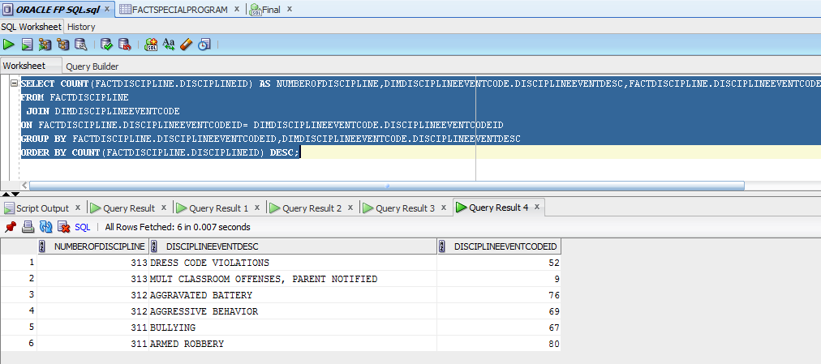

2

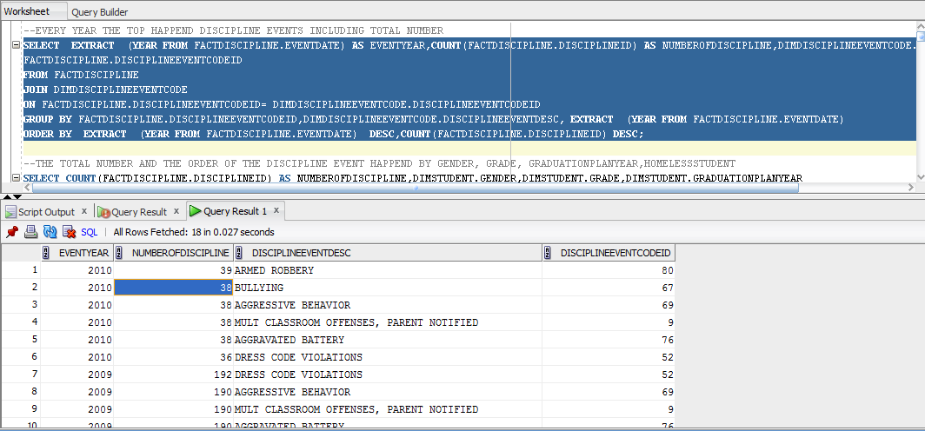

3

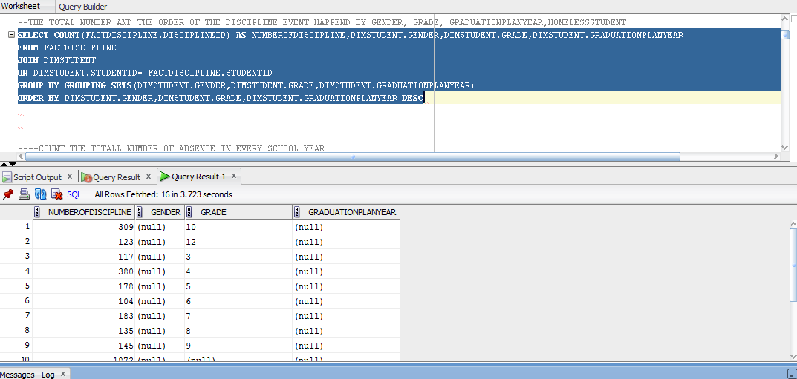

4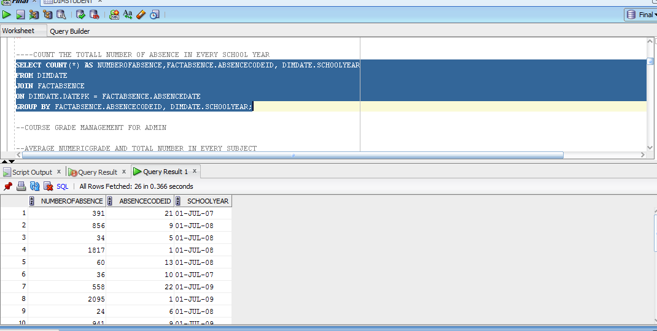

5.

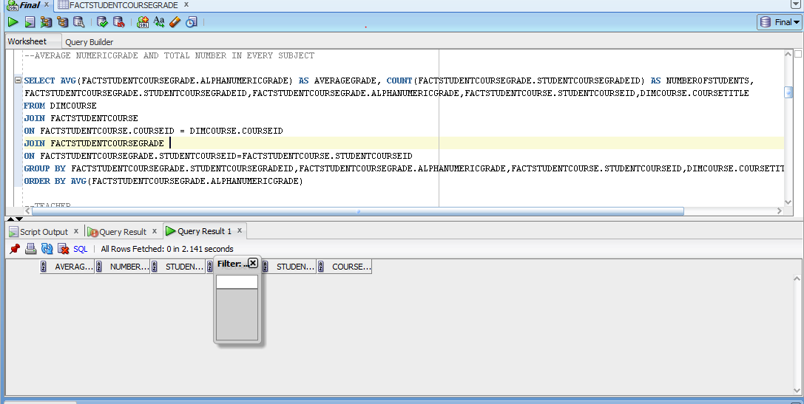

6.

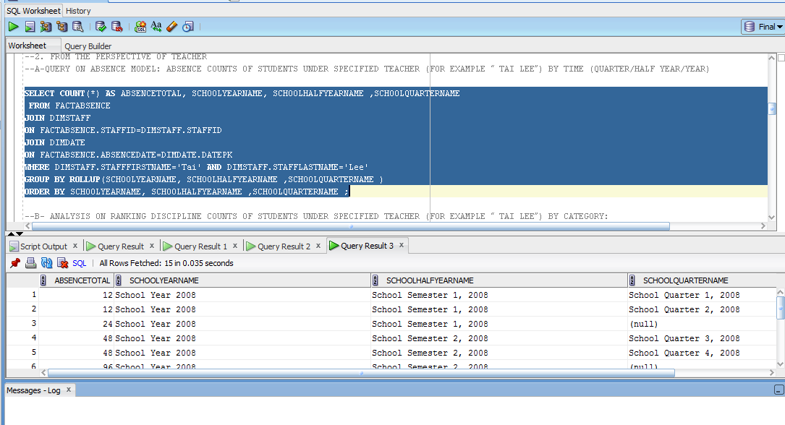

7.

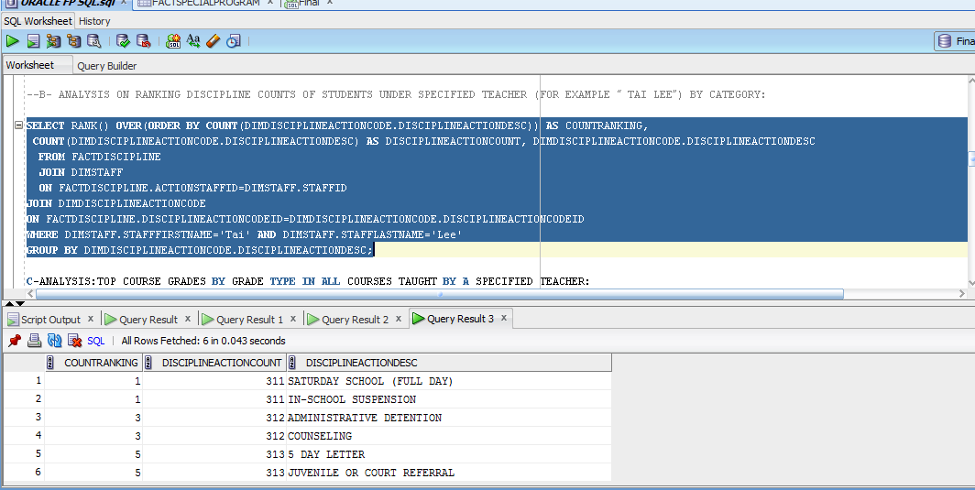

.

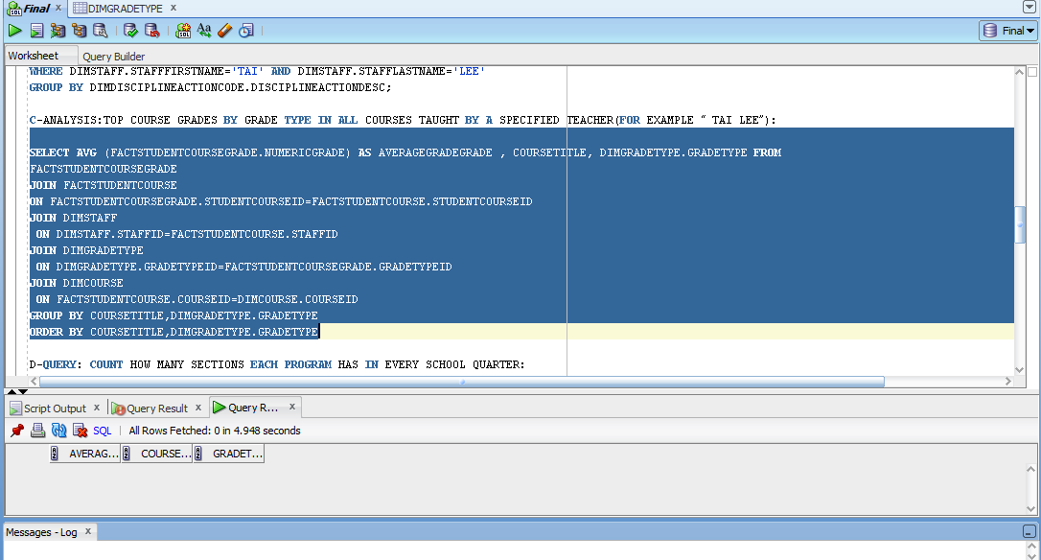

9

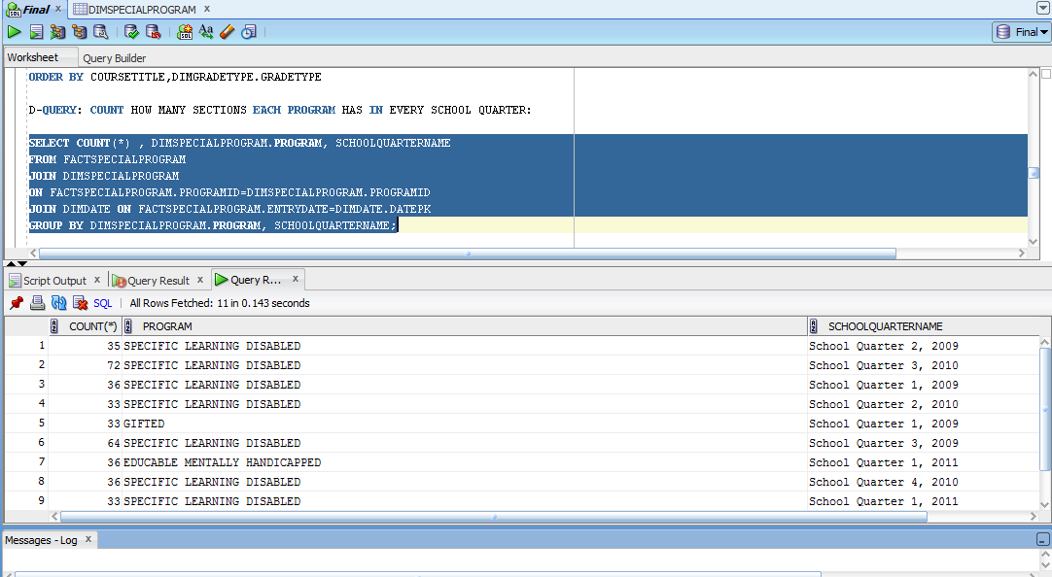

10.

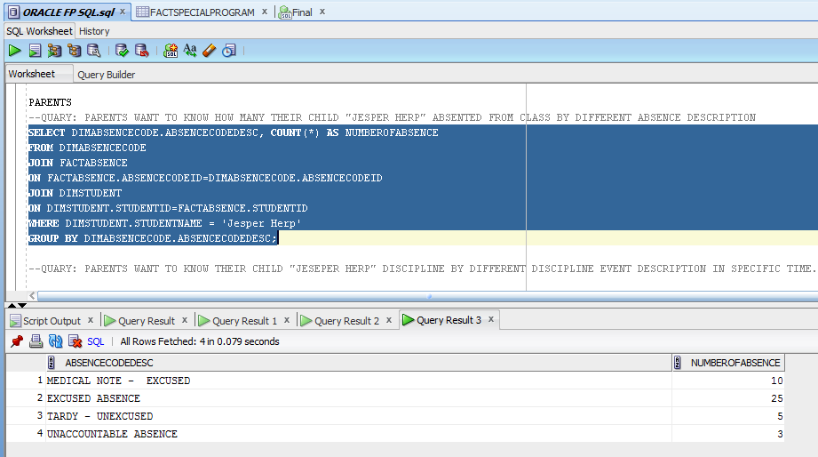

11.

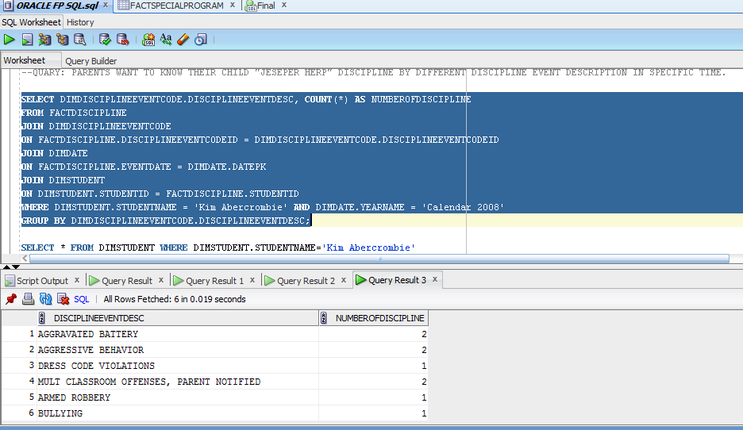

12.

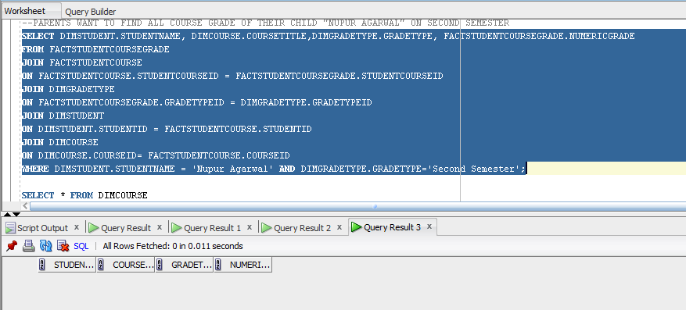

13.

